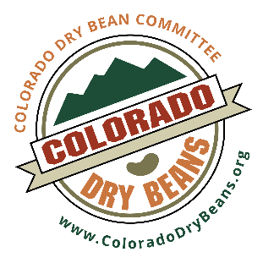
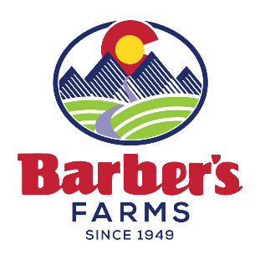
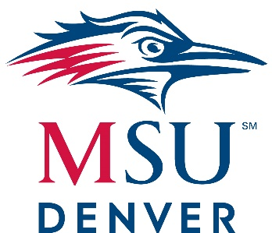

Colorado Bean Summit | Friday, September 24, 2021 | Metropolitan State University of Denver

1190 Auraria Parkway, Denver, CO 80204

Presenting Sponsor Colorado Dry Bean Council
Opening Sponsor Barber’s Farms
Reception Sponsor School of Hospitality, Tivoli Brewery

Nonprofit Honoree We Don’t Waste

8:00 AM- 9:00 AM Reception with Meet and Greet
Coffee, Tea, Pastries, Fruit, Fresh Municipal Tap Water
Alumni Lounge
Poster Competition on display in HLC 200 and 202

9:00-9:20 AM Opening Remarks Culinary Demonstration Theater
Professor Jackson Lamb, MBA, CHE, MSU Denver
Dr. Henry Thompson, Ph.D. Colorado State University
Director of CSU’s Cancer Prevention Laboratory
Bob Schork, Colorado Dry Bean Committee
Greg Bloom, Barber’s Foods

9:30-10:00 AM Breakout session #1 Room 200 30 minutes (Speakers switch rooms)
“Building a Foundation for Closing the Dietary Fiber Gap: Improving Gut Health through a Diverse Diet”
Dr. Henry Thompson, Ph.D. Colorado State University
Director of CSU’s Cancer Prevention Laboratory
Nutrien Distinguished Scholar of Agricultural Sciences

Breakout session #2 Room 202 30 minutes (Speakers switch rooms)
“Beans and Rice; Health Benefits of a Plant-Based Diet”
Professor Jennifer Watson, MSU Denver, School of Hospitality

10:00-10:30 AM Breakout session #3 Room 202 30 minutes (Speakers switch rooms)
“Building a Foundation for Closing the Dietary Fiber Gap: Improving Gut Health through a Diverse Diet”
Dr. Henry Thompson, Ph.D. Colorado State University
Director of CSU’s Cancer Prevention Laboratory
Nutrien Distinguished Scholar of Agricultural Sciences

10:00-10:30 AM cont. Breakout session #4 Room 200 30 minutes (Speakers switch rooms)
“Beans and Rice; Health Benefits of a Plant-Based Diet”
Professor Jennifer Watson, MSU Denver, School of Hospitality

10:30-11:30 AM Demonstration Culinary Demonstration Theater 60 minutes
“The Southwestern Influence with Beans and Rice”
Sandra Ortega and Antonio Garcia, working with Bolita Beans

11:30-12:30 PM Beverage Bar Refresh
Lunch Buffet; Box Lunch options set up in Alumni Lounge
Ham, turkey, vegetarian or vegan
Sampling of International Bean and Rice Dishes; Kitchen 106, using Award
winning recipes from students at MSU Denver

12:30-1:00 PM Breakout session #5 Room 200 30 minutes (Speakers switch rooms)
“Journey Through Our Heritage”
Department of Chicana/o Studies
Metropolitan State University of Denver

Breakout session #6 Room 202 30 minutes (Speakers switch rooms) “Increasing Bean Consumption: Mitigating Barriers and Emphasizing
Motivators”
Dr. Chelsea Didinger, Ph.D. Colorado State University

1:00-1:30 PM Breakout session #7 Room 202 30 minutes (Speakers switch rooms)
“Journey Through Our Heritage”
Department of Chicana/o Studies
Metropolitan State University of Denver

Breakout session #8 Room 200 30 minutes (Speakers switch rooms) “Increasing Bean Consumption: Mitigating Barriers and Emphasizing
Motivators”
Dr. Chelsea Didinger, Ph.D. Colorado State University

1:30-2:00 PM Breakout session #9 Room 202
“Supporting Denver’s Food Deserts; How Bad is Food Insecurity?”
Matt Karm, Julia Lennon, with We Don’t Waste

Breakout Session #10 Room 200
“Distribution Woes, Dried Beans vs. Canned Beans and Rising Fuel Costs”
Greg Bloom, Barber’s Farms

2:00-2:30 PM Breakout session #11 Room 200
“Supporting Denver’s Food Deserts; How Bad is Food Insecurity?”
Matt Karm, Julia Lennon, with We Don’t Waste

2:00-2:30 PM cont. Breakout Session #12 Room 202
“Distribution Woes, Dried Beans vs. Canned Beans and Rising Fuel Costs”
Greg Bloom, Barber’s Farms

2:30-3:30 PM Beans and Rice Poster Session Competition Judging and review
MSU and CSU student research poster competition on the properties of
Beans, Legumes and Rice. 4 categories for submittal:
- International Beans and Rice; It’s in Every Cuisine
- Nutritional Benefits of a Beans and Rice in your Diet
- Feeding a Starving Population; Are Beans the Answer?
- Sustainability and Economics; Dry Beans vs. Canned Beans
$500 awarded to best poster in each category
Wrap up from here

3:30-5:00 PM Happy Hour Reception at Tivoli Brewery
The first beverage is sponsored by the School of Hospitality. This
reception will feature bean-inspired passed hors d’oeurves and Mexican-
style lager beer!

